# [WWW.Jio.com-](http://WWW.Jio.com-) Analysis and improvement recommendations

**PART-1:**

1. *I have choosen the website of one the biggest internet and communication network provider of INDIA. Despite being the biggest network provider they are lacking in good SEO strategy. Various problem is faced by any user to open this site and site is throughly filled with Images and complex designing. Keywords are not used properly which make this side rank below when searched about any international network provider*.

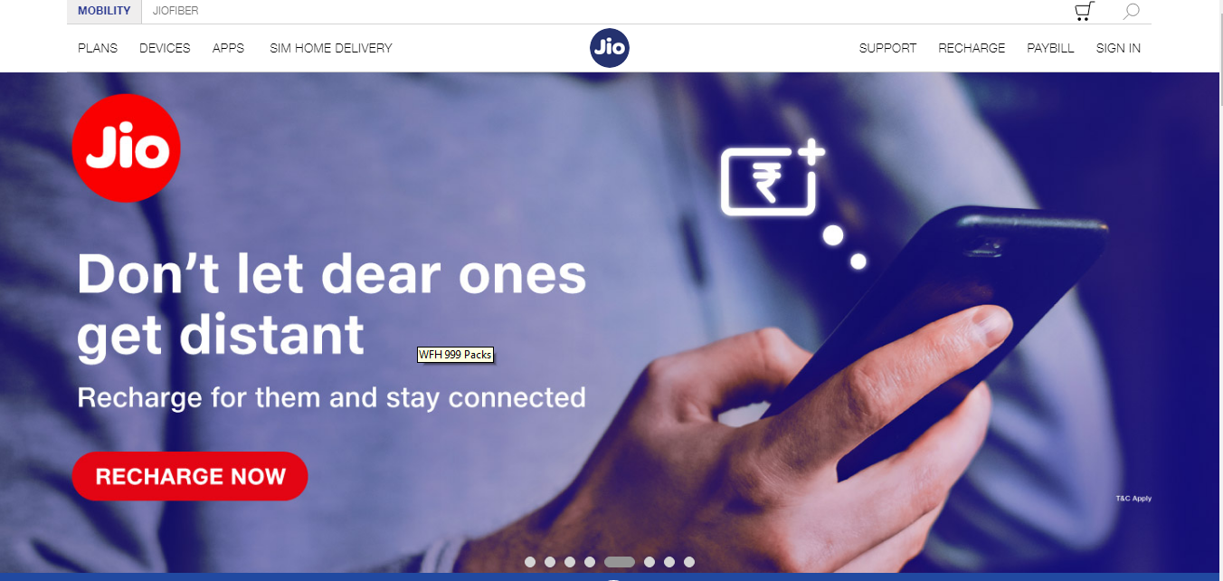

*Site snippet*

1. *For Reliance to get more subscriber there long tail keyword should be more relivant to there current work like:-*
2. *New Networking-Fibre-\Jio-Fibers*
3. *Connecting the world-\Jio-INDIA. Etc*

*For Relaince Jio the main question-base keywords maybe :*

1. *How- Home-Connection, contact us for connection ,etc.*
2. *What- Jio-Fibre, High-speed Internet Connection,etc.*
3. *Where- Connection throughout INDIA, Connecting India ,etc*
4. *Why- Tower in remote areas, 24x7 network ,etc.*
   1. *Target audience of this site is all Indians customers as such it is not giving any Network subbscription throughout the world. Moreover now this Site majorly support there new product: “JIO-FIBRE”. Mobility option on the dashboard of the side provisde various other option of other network connectivity option.*
      * *It is not a gender based Site.*
      * *As mentioned majority audience are from India,as it is based on Indian networking buisness.*
      * *Primary traffic source of this website is the whole connection freak people who want there internet to work in good speed.*

*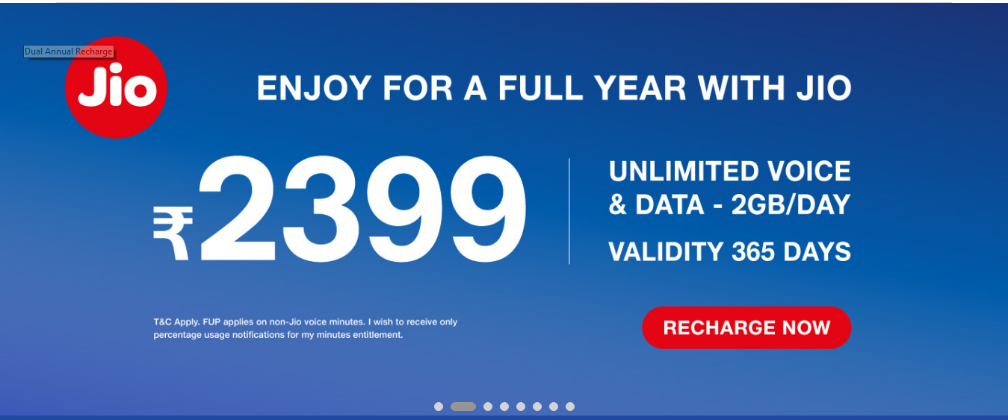 Keyword used :- Unlimited Voice and Data, Recharge.*

**PART-2*:-***

* + 1. ***Home-Page:-***
* Page <URL:-> <https://www.jio.com/>
* Title Tag:- Jio 4G LTE Network - Experience High Speed 4G -Mobile Internet
* H1 Tag:- The World's Largest Data Network Based on Mobile Data Consumption
* H2 Tag:- Affordable, cutting-edge devices
  + 1. ***Page-1:-(Plans)***
* Page <URL:-> [www.jio.com/en-in/4g-plans](http://www.jio.com/en-in/4g-plans)
* Title Tag:- Jio Prepaid Recharge Plans - Online Mobile Recharge & Offers
* H1 Tag;- no heading tag
* H2 Tag:- Data packs
  + 1. ***Page-2:- (Devices)***
* Page <URL:-> <https://www.jio.com/shop/en-in/c/jiofi>
* Title Tag:- Portable Wifi Hotspot & Routers - Enjoy 4G with JioF
* H1 Tag:- No tag
* H2 Tag:- Filters
  + 1. ***Page-3:-(APPS)***
* Page <URL:-> www.jio.com/en-in/apps
* Title Tag:- Jio Apps Download - Entertainment, News, Social & Utility Apps
* H1 Tag;-
* H2 Tag:- Life is Beautiful with Jio Apps